Hanging Heaton CE (VC) J&I School

Positive Behaviour Policy
2025 – 2026
Our Vision
‘Let all that you do be done in love’ – (1 Corinthians 16:14)
We aim to develop our children academically, socially, morally, culturally and spiritually to help them to be more valued and responsible citizens

Our vision underpins all that we do in school This vision is supported by our Key Christian Values are:
Trust
Compassion
Forgiveness
Thankfulness
Creativity
Wisdom

These are an essential part of our school lives, allows us to serve our community by providing a high-quality education within the context of Christian belief and practice.
Love for Learning
We are all on a fun learning journey in order to achieve our full potential
We celebrate and share our successes and achievements
Love for Ourselves
We promote a positive, healthy lifestyle and aim to make ourselves the best we can be
We all have our own thoughts, gifts, talents, skills and abilities
Love for One Another
We look after one another and show care for everybody
We respect the beliefs and cultures of all communities
Love for our World
We work together to create a warm, safe and stimulating environment
We act to take care of our wonderful world
Aims and Objectives
- To promote a positive ethos in the school (be ready to learn, be respectful, be responsible), which reflects our Christian character and values.
- To ensure our children understand the school vision and how this relates to their attitude and behaviour in and outside of school.
- To create an atmosphere of trust and respect where each child is able to fulfil their potential and become confident, responsible and increasingly independent members of the school community.
- To provide a safe, calm, supportive and pleasant environment both for children and adults, where all members of the school community are valued and where offline and online bullying is always unacceptable.
- To help children develop self-awareness and understand and manage their own feelings and behaviour.
- To help children develop and maintain positive relationships with others.
- To achieve the highest possible standards in all areas.
- To ensure that children feel important and that they know that they belong.
- Children are positively noticed in school and that they have a right to this.
- Deliberate botheredness is a daily act – authentic care which is real and deliberate which supports young people to be on board with learning. Adults relationship building with children is done slowly.

Being Genuine
- It is the job of adults to get to know the children who are in their care.
- Children need to feel valued in school.
- Adults need to mean the praise that they give to the children; praise given should be genuine
- Adults should talk to each other about children behaving well. This allows other adults to seek out these children and also praise them.

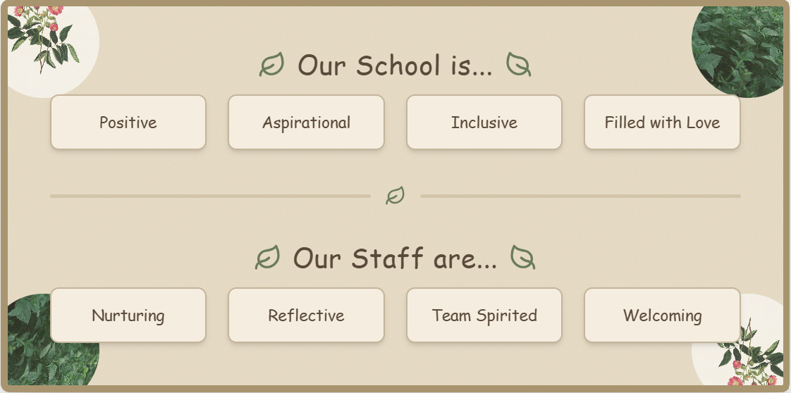

This policy has strong links with other policies and should be read in conjunction with the Anti-Bullying Policy.

Our Children Are Expected To
Follow our School Promises and to remember we are a ‘telling school’, that supports each other as a caring school family. Our School Promises are reviewed regularly in consultation with all pupils and staff.
Our School Promises
Our School Promises are rooted in our Christian vision: “Let all that you do be done in love” (1 Corinthians 16:14). This vision shapes how we build relationships, support behaviour, and enable all members of our community to flourish. By living out love through kindness, respect, and forgiveness, we create a safe, inclusive environment where every individual is valued and encouraged to grow.
We understand Love as an active and intentional choice: expressed through compassion, respect, forgiveness, and service to others. It is through this lens that we promote high expectations of behaviour, rooted not in compliance alone but in the development of character and moral responsibility.
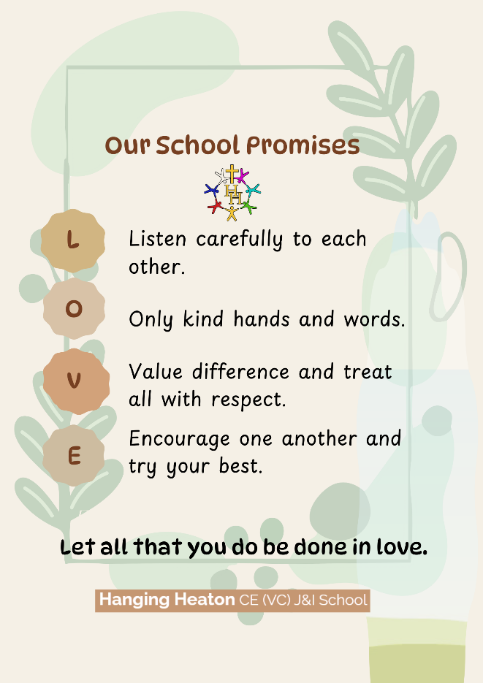
Our School Promises provide a clear and meaningful framework for living out this vision:
- Listening carefully to each other reflects our commitment to valuing every individual, ensuring that all voices are heard and respected.
- Using kind hands and words demonstrates care for others, creating a safe and supportive environment where all feel a sense of belonging.
- Valuing difference and treating all with respect affirms the dignity of every person and celebrates the richness of diversity within our community.
- Encouraging one another and striving to do our best promotes resilience, aspiration, and a culture where all are supported to flourish.
Within this approach, behaviour is understood as relational. We prioritise restoration over punishment, supporting children to reflect, take responsibility, and rebuild relationships when difficulties arise. Forgiveness and reconciliation are key, enabling pupils to learn from mistakes and move forward positively.
By placing Love at the centre of our behaviour policy, we cultivate a community where dignity is upheld, positive relationships are nurtured, and all individuals - pupils and adults alike - are empowered to grow and flourish. Our vision is lived out daily through our actions, ensuring that love is evident in all that we do.
Rewards
We recognise that rewards and praise for good behaviour are far more effective, and positive, than consequences are for poor behaviour. It is our intention that the system for rewarding and praising good behaviour should play a far more important role in the day to day running of the school, than should sanctions.
Rewards systems to be used in school include the following:
Type of Reward | Reason | Given By
Verbal | - Adults give out lots of verbal praise for lots of different reasons.  - Never underestimate the impact of verbal praise. | All adults
Stickers | - Given to children who have completed work/answered questions/followed instructions/made the right choices | All adults
Dojo Points | - Complete Mathletics/SPaG Homework  - Reading 4x per week  - Following the school promises  - Receiving the lunchtime award  - Being on task in lessons  - Participating in lessons  - Persisting in lessons  - Positive attitude to learning  - Teamwork  - Being ready to learn | All adults
Dojo Champion of the Week Certificate | - Given to a child/children in each class who have been rewarded with the most Dojo Points that week | Headteacher/Deputy Headteacher
Dojo Champion of the Half Term | - Given to a child/children in each class who have been rewarded with the most Dojo Points in a half term  - This reward is “Hot Chocolate with Mrs Caspell” | Headteacher/Deputy Headteacher
Dojo Champion of the Term | - Given to a child/children in each class who have been rewarded with the most Dojo Points in a term  - This reward is a gift voucher for the child to spend | Headteacher/Deputy Headteacher
Star of the Week | - Recognising children who consistently make good choices and show respect for our classroom and school expectations.  - Celebrating those who demonstrate our core school values in their daily actions.  - Highlighting pupils who set a positive example through their behaviour, attitude, and effort both in and out of the classroom.  - Praising children who keep trying, show resilience, and don’t give up when faced with challenges.  - Acknowledging pupils who make connections in their learning and use what they’ve been taught to improve and extend their work.  - Celebrating kindness, empathy, and supportiveness — children who include others and help make our class a caring community. | Class Teacher
Lunchtime Munch Award | - Using excellent manners consistently during lunchtime.  - Showing a positive and polite attitude while having dinner.  - Demonstrating respect for dinner staff and fellow pupils.  - Following lunchtime routines and school expectations.  - Being considerate and helpful to others in the dinner hall.  - Creating a friendly, welcoming, and positive atmosphere at mealtimes.  - Showing self-discipline and making good choices in the dining area. | Kitchen Staff
Deputy Headteacher and Headteacher Awards | - Showing exceptional effort and commitment to learning.  - Demonstrating perseverance and resilience when faced with challenges.  - Producing outstanding work or making significant progress.  - Consistently showing kindness, respect, and care for others.  - Displaying the school’s core values in everyday behaviour.  - Using creativity and curiosity to extend their learning.  - Being a positive role model and setting a good example for others.  - Making a notable contribution to the school community or class.  - Showing a positive attitude and enthusiasm for school life.  - Going above and beyond expectations in both learning and behaviour.

Actions and Consequences
In the main, it is intended that class teachers will manage the behaviour within their classrooms and will support children through applying consistent classroom promises and behaviour management strategies to maintain positive behaviour. Where behaviour becomes extreme, Senior Leaders will intervene to support and parents will be engaged in order to work in partnership to achieve an improvement.
The following actions and consequences have been discussed, and agreed, by the children and staff in school. They will be reviewed annually.

Consequence Stages
Stage 1: Reminder | Gentle encouragement in the right direction for what’s expected in class/around school.  Non-verbal cues/acknowledgement
Stage 2: Verbal Warning | A reminder of the school promises.  The adult makes the child aware of their behaviour and the learner has a choice to do the right thing.  De-escalate and decelerate where reasonable and possible and take the initiative to keep things at this stage.  Repeat reminders if reasonable adjustments are necessary.  Praise will be given to the learner if they are able to model good behaviour as a result of the reminder.
Stage 3: Written/Visual Warning | At the written/visual warning stage. Pupil spoke to and adult to give them the final opportunity to engage.  Offer positive choices to do so and refer to previous examples of good behaviour.  Time out may be required to deescalate and decelerate.  Restorative practice will be used with the child  5 of these questions is usually enough from the following:  - What happened?  - What were you thinking at the time?  - What have you thought since?  - How did it make people feel?  - Who has been affected?  - How have they been affected?  - What should we do to put things right?  - How can we do things differently in the future?  Reset expectations, repair and settle back in
Stage 4: Ticket | Child will be sent to a member of the senior leadership team if behaviour continues to not meet the expected standards.  Parents will be contacted about their child receiving the ticket and the reasons why.  Any work which the child has not completed in lesson time will be completed at lunch time or that evening, countersigned by parent and returned first thing. The latter is to help the child understand that there are consequences and the responsibility for making up for lost learning time is with them and not the teacher.
Stage 5 – Behaviour Communications & Subsequent Meetings | - The decision to escalate to Step 5 will be determined by behaviour lead/SLT when considering evidence around each situation  - The decision will also be made when children are persistently being at Stage 3 and 4  - A member of school staff will also speak with the child about the choices in behaviour.  - The First Communication  - Includes a meeting with parents/carers, class teacher and behaviour lead  - Children’s voice will also be shared  - The Second Communication  - Includes a meeting with parents/carers, class teacher, behaviour lead and a member of SLT  - Children’s voice will also be shared  - The Third Communication  - This will initiate an individual behaviour plan.  - This could be introduced earlier if deemed necessary by the class teacher, behaviour lead, SLT and parents/carers.  Children’s voice will also be shared
Individual Behaviour Plans (IBP) | - These replace the consequence system for a small number of children who require reward, consequences and chains of communication with parents/carers to be more personalised.  - The leadership team, class teacher and possible input from the SENDCO and external agencies will determine when the IBR is correct.  - Parents/carers will be invited to a meeting to discuss the IBR  - Children can be taken off IBRs at the discretion of school leaders and through discussions with parents.  - IBP Expectations  - Separate reward and consequences with differing thresholds – as required;  - Weekly Individual Record sheets must be completed and passed to the Behaviour Leader at the end of every week;  - Clear, regular communication with parents/carers must be established and maintained. This may involve: daily ‘home communication books’; weekly ‘phone calls/meetings’; contact when an Individual Behaviour Record event of note occurs.  - Risk Assessments may be required - as may a detailed Individual Behaviour Plan.  Engagement with the SENDCo and external agencies may be required.
Restrictive Interventions (Including the Use of Reasonable Force)
The school recognises that the use of restrictive intervention, including reasonable force, is a safeguarding matter and will always be approached with the utmost care.

Core Principles
The school is committed to:
- Minimising the need for restrictive interventions through early support, positive behaviour guidance and de-escalation strategies
- Using restrictive interventions only when absolutely necessary, lawful, proportionate and for the shortest possible time
- Prioritising the safety, dignity and welfare of pupils and staff
All actions will comply with:
- Education and Inspections Act 2006 (Sections 93 & 93A)
- Schools (Recording & Reporting of Seclusion and Restraint) Regulations 2025
- Equality Act 2010
- Human Rights Act 1998

Prevention and De-escalation
The school places a strong emphasis on prevention and de-escalation.
Before considering any restrictive intervention, staff will:
- Use calm, non-confrontational communication
- Offer time, space and sensory regulation opportunities
- Adjust demands where appropriate
- Remove triggers or environmental stressors
- Seek support from colleagues
- Use strategies identified in Behaviour Support Plans
- Restrictive interventions will only be considered where other approaches have been ineffective or are judged to be inappropriate in the circumstances.

When Restrictive Interventions May Be Used
A restrictive intervention may only be used when:
- There is an immediate risk of harm to the pupil or others
- Serious disorder is occurring
- Significant property damage is imminent
- No less restrictive measure would be effective
Staff will consider the child’s:
- Age and developmental stage
- SEND profile
- Trauma history
- Communication needs
- Physical health and vulnerabilities
- Interventions must stop as soon as the immediate risk reduces.

Reasonable Force (DfE Definition 2026)
Staff may use reasonable force to prevent a pupil from:
- Injuring themselves or others
- Causing serious disorder
- Damaging property
- Committing a criminal offence
Any use of force must be:
- Necessary
- Proportionate
- For the shortest possible time
- Never used as punishment
- Reasonable force will always be a last resort.

Safeguarding and Safety
Restrictive interventions carry inherent risks. Therefore:
- Techniques that restrict breathing, or apply pressure to the neck, chest or abdomen must never be used
- Prone (face-down) restraint must never be used
- Interventions must preserve the pupil’s dignity and welfare

Prohibited or Dangerous Practices
The following are strictly prohibited:
- Using force as punishment
- Restricting breathing, airway or circulation
- Prone restraint (face-down)
- Using force to inflict pain
- Threatening seclusion
- “No contact” policies that prevent staff from keeping children safe

Supporting Children with SEND
We recognise that some children may have difficulties regulating behaviour due to SEND, trauma, or communication needs.
Staff will:
- Understand underlying triggers
- Use prevention and de-escalation strategies
- Implement reasonable adjustments
- Co-produce Behaviour Support Plans with parents, SENCO and professionals
- Ensure any planned physical intervention is clearly documented
- Complete risk assessments where interventions may be foreseeable
- Plans will be reviewed regularly and after any incident.

Seclusion
Seclusion will only be used in exceptional circumstances to prevent serious harm.
It will:
- Never be used as punishment
- Be used for the shortest possible time
- Be continuously monitored
- End as soon as it is safe
- Staff must never use seclusion as a threat.

Staff Training and Safety
Staff likely to use physical intervention will receive accredited training aligned with 2026 guidance:
- TeamTeach remains in use, with updates applied
- Staff must not place themselves at unreasonable risk
- Risk assessments will be in place where needed

Recording and Reporting (Statutory Requirement – April 2026)
Recording
All significant incidents must be recorded:
- By staff involved
- As soon as practicable (same day where possible)
- Records will include:
- Pupil and staff names
- Date, time, duration and location
- Triggers and de-escalation strategies used
- Reason intervention was necessary
- Type and level of force used
- Injuries or distress caused
- SEND/vulnerability considerations
- Post-incident actions and medical checks
- Parent notification details
- Reporting to Parents
Parents/carers will be informed:
- As soon as practicable
- Usually on the same day
Written communication will include:
- What happened
- Why intervention was necessary
- Duration
- Any injuries
- Follow-up meetings will be offered.
Note:
Any use of seclusion must be recorded and shared with parents, even if no force is used.

Post-Incident Support
Following any restrictive intervention:
- The child will receive emotional and physical support
- A restorative conversation will take place where appropriate
- Staff will receive debrief and support
- Witnessing pupils will be supported
- Behaviour plans and risk assessments will be reviewed
- Patterns and triggers will be analysed

Definitions (DfE 2026)
Restrictive Intervention:
Any action (physical or non-physical) that restricts a pupil’s movement or liberty.
Handling:
Physical contact intended to support or guide a pupil (may be restrictive or non-restrictive).
Restraint:
Direct or indirect actions that immobilise or limit movement.
Reasonable Force:
Necessary and proportionate force used to achieve a legitimate outcome.
Seclusion:
A non-disciplinary intervention where a pupil is prevented from leaving a space for safety reasons only.

Governance and Oversight
The Governing Body will:
- Monitor incident data regularly
- Ensure statutory compliance
- Identify patterns, including any disproportionate impact on SEND or EAL pupils
- Support improvements in training, systems and preventative approaches
Exclusions
Only the Headteacher or Deputy Headteacher (in the head’s absence), has the power to exclude a pupil from school. This would be used as a last resort, in line with the LA guidance on fixed term or permanent exclusions and in consultation with the Governing Body.
Parents and the LA would be informed immediately and parents would be reminded of their right to appeal against the decision.

Restorative Justice
Restorative practice is a set of principles and practice that encourages children to take responsibility for their behaviour by thinking through the causes and consequences.
In a promise-led system, the tendency is for the teacher to tell the child what they’ve done wrong, and how they will be punished for it. However, we believe that in such a system, children do not learn about the responsibility they had in that situation and how it affected other people, because it is an adult who has intervened and told them what they have done wrong.
Restorative practice, on the other hand, involves helping the child think through their behaviour, its consequences and what they can do to make it better.
At Hanging Heaton, our vision involves conducting oneself in a positive and considered manner and building a community based around being mindful of others, where children take responsibility for their own behaviour.
Restorative practices centre around a set of key questions that help children think about their behaviour and understand how they can correct it:
The following questions may be used:
• What happened?
• Which part were you responsible for?
• What choice did you make?
• What choice could you have made?
• What were you thinking at the time?
• What have your thoughts been since?
• Who has been affected by this and in what way?
• What do you think could make it right?
• What could have been done differently?
• Was it the right or wrong thing to do?
• Was it fair or unfair?
• What are you sorry for exactly?
• What could you do to avoid this again?

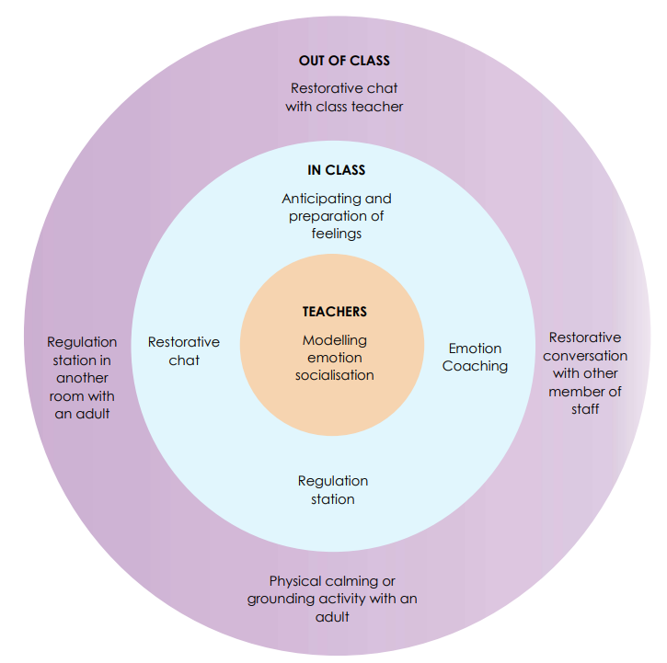
Emotion Coaching
We use Emotion Coaching to support children to understand, regulate and reflect on their behaviour. These steps are used primarily for the reflection time as identified above and also for those children with specific educational needs whose plan suggests that an alternative approach is required to assist them with their social and emotional wellbeing. This alternative approach will also include Zones of Regulation work.
Steps and Responsibilities of Emotion Coaching
Step 1 - Recognising the child’s feelings and empathising with them.
Step 2 - Label the feelings and validating them (validating = let the child know why they might be feeling like this and that this is okay)
Step 3 - Set limits on the behaviour (if needed)
Step 4 - Problem-solve with the child

The Role of Staff
All staff at Hanging Heaton follow the school’s code of conduct and behaviour policy. Our school vision underpins everything we do as a school. To achieve this vision, the staff will:
- Ensure this policy is implemented
- Be good role models for others
- Implicitly and explicitly teach our children our behaviour expectations in school
- Have high expectations of pupils’ behaviour
- Promote a positive working atmosphere throughout the school
- Monitor behaviour on a regular basis and keep regular contact with parents about any concerns. Inform the Headteacher if any parent has had to be spoken to about their child causing concern. Keep a record of such conversations and decisions made and agreed.
- Be around school at key points during the day, especially playtimes and lunchtimes and start and end of day
- Support pupils in completing ‘Thinking Sheets’
- Provide support for staff where there is negative behaviour
- Offer a wide range of rewards and sanctions
- Use a wide range of appropriate behaviour management strategies including ‘Team Teach’ positive handling strategies for pupils (See Reasonable Use of Force guidance https://www.gov.uk/government/publications/use-of-reasonable-force-in-schools and Appendix 1)
- liaise with parents and external agencies
- Ensure children’s’ views are heard
- Give children responsibilities
- Be alert and responsive to signs of bullying (online and offline), racism, HBT comments, discrimination, sexualized comments and actions.
- Keep records of incidences of misbehaviour on CPOMs.
- Inform the Headteacher and ensure legal records are kept for all serious incidences, racism and bullying using the appropriate recording system
Staff development and Support
As a caring school community, we work with one another to ensure that all staff are supported when dealing with behaviour issues to ensure a clear and consistent approach. Our SENDCo liaises with other agencies to arrange staff development sessions where needed for individual pupils. The SLT will be on hand to support where needed.
The Role of Parents/ Carers
We recognise the importance of school and home adopting a consistent approach to behaviour management that is built on mutual respect and trust. Parents are encouraged to support and trust us, and we in turn ensure that we deal with all incidents fairly and consistently.
Parents are informed of the school’s Positive Behaviour and Anti Bullying Policy through newsletters, policies sent home, induction for new parents’ meetings and the prospectus.
Parents’ views are taken very seriously. They are actively encouraged to meet with the class teacher in the first instance and to remember that the Headteacher is always available for any worries or concerns. The school has an Open Door Policy but parents may be asked to make appointments if concerns cannot be quickly dealt with and more lengthy discussions are required. The class teacher will also inform parents about incidents wherever appropriate. It is important that effective communication between home and school is maintained.
Equality
This policy also takes into account and reflects the school’s Equality, Diversity and Cohesion Policy, the findings of the ‘Stephen Lawrence Enquiry’, LA Guidelines, our duty to promote Disability Equality, our Inclusion Policy and the Equality Act 2010. When carrying out positive behaviour management and anti bullying strategies in school, staff will have equal expectations of all our pupils.
Review
The Policy will be annually reviewed by all pupils, staff and Governors. The Governing Body and Headteacher are responsible for making sure this review happen and that any amendments/ alterations are agreed and in line with Government and LA guidance.
Positive Behaviour Policy (Updated to include April 2026 Statutory Guidance on Restrictive Interventions)

This updated policy integrates the DfE’s new statutory requirements for recording, reporting
and implementing restrictive interventions and reasonable force (effective April 2026).

